Introduction
This write-up refers to the Evil Corp machine. The machine contains LAPS vulnerabilities, allowing attackers to gain administrative access within Active Directory. If you require support, please open a ticket in the support channel on the Discord server..

Reconnaissance
We begin by running an nmap scan.

nmap -sVC 172.16.8.223 --min-rate 1000

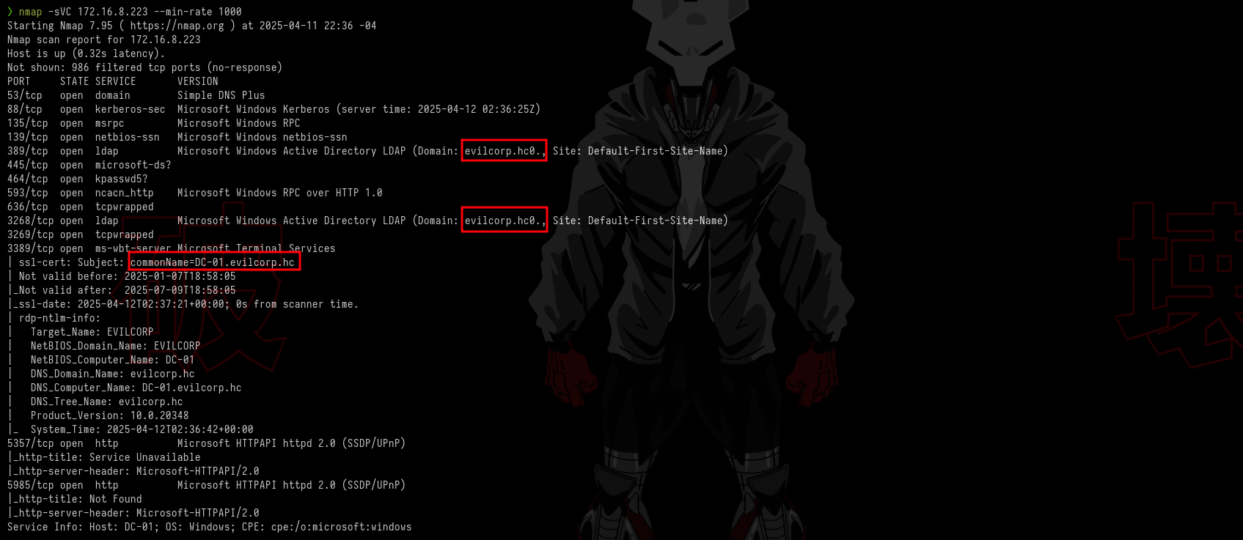Figure 1 - nmap command results.
Here we can see the domain and services available for enumeration. We have Kerberos on port 88, SMB on ports 135 and 445, LDAP on ports 389 and 3268, and RDP on port 3389. Regarding the domain, we need to add it to our /etc/hosts file.

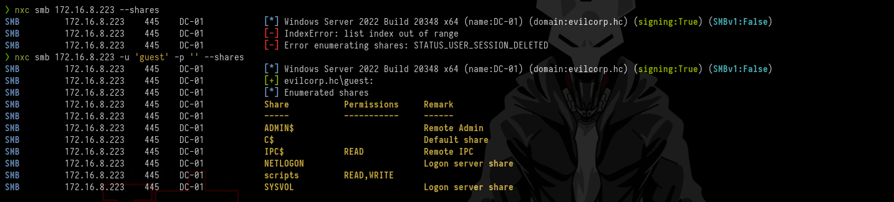Figure 2 - Enumerating SMB.

We use netexec to enumerate SMB. NetExec is a comprehensive tool that can perform both enumeration and assist in exploitation, supporting multiple services such as SMB, LDAP, among others.
nxc smb 172.16.8.223 --shares

Initially, anonymous authentication does not work. However, pre-authentication with the guest user works successfully. With it, we discover the “scripts” share. We can access it using smbclient.

smbclient //172.16.8.223/scripts -N

Inside the share, we find a script that is executed periodically to keep backup files updated.

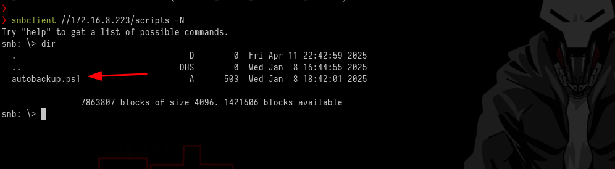Figure 3 - Script in the scripts directory.

Exploitation – obtaining the user flag

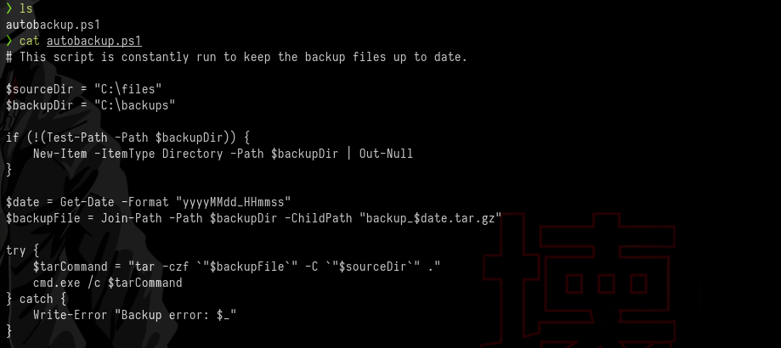Figure 4 - Script content.

What does this script do? Essentially, it is designed to automatically back up files. It creates a folder if necessary, compresses the contents of C:\files using tar, and saves the compressed backup into C:\backups with a timestamp in the filename.
With this in mind, we can modify the script by adding a reverse shell payload. If it is executed through a scheduled task, it will trigger the script and return a shell to us.

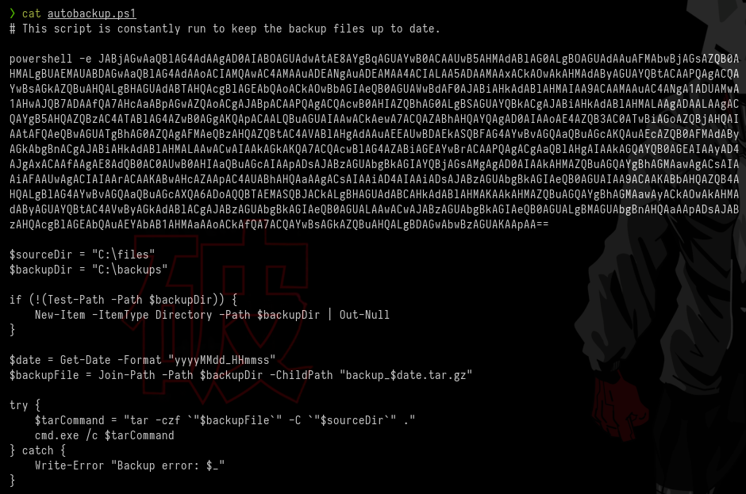Figure 5 - Adding a reverse shell command to the script.

We then upload the modified script back into the scripts share, replacing the original file. As a result, we obtain a shell as the user “evilcorp\phillip”.

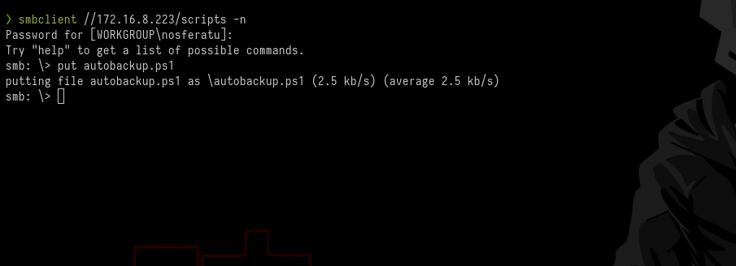Figure 6 - Uploading the modified script to SMB.

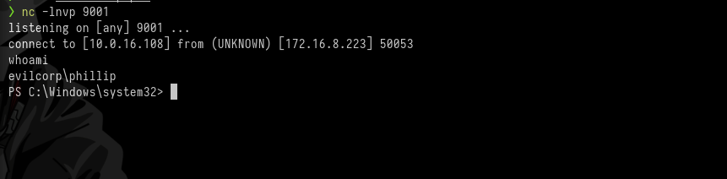Figure 7 - Obtaining reverse shell.
With this, we navigate to phillip’s user directory and retrieve our first flag.
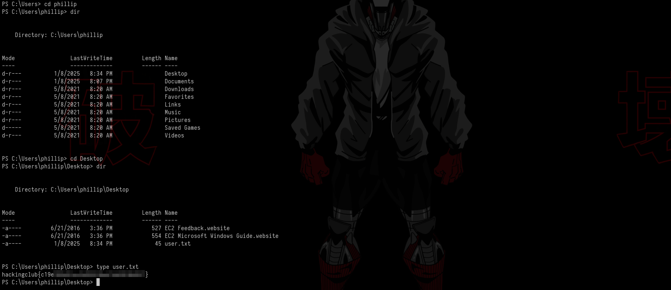Figure 8 - Capturing the user flag.

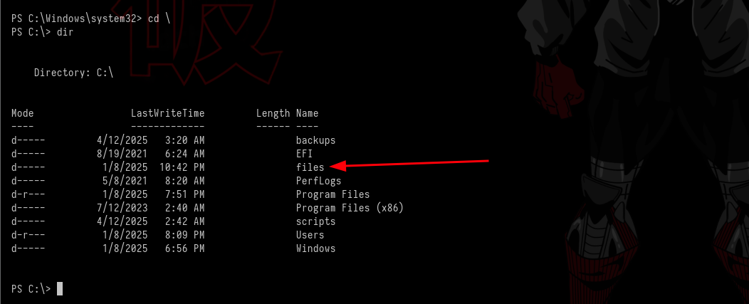Figure 9 - Enumerating the system.

We continue enumerating the machine until we reach the C:\files directory, which contains a file named “important.txt.txt”, but it does not contain anything useful XD. However, in the same folder, we find a directory named after the user.

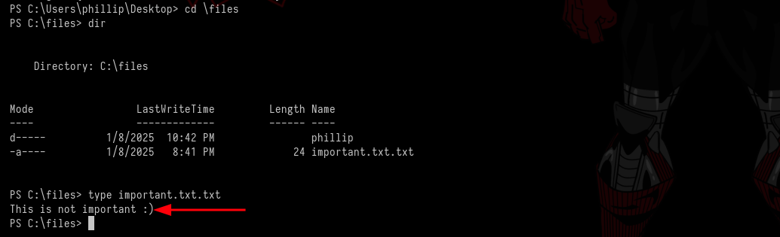Figure 10 - Non-important files.
Inside this directory, there is a file named “logins.txt” containing credentials for the user phillip.

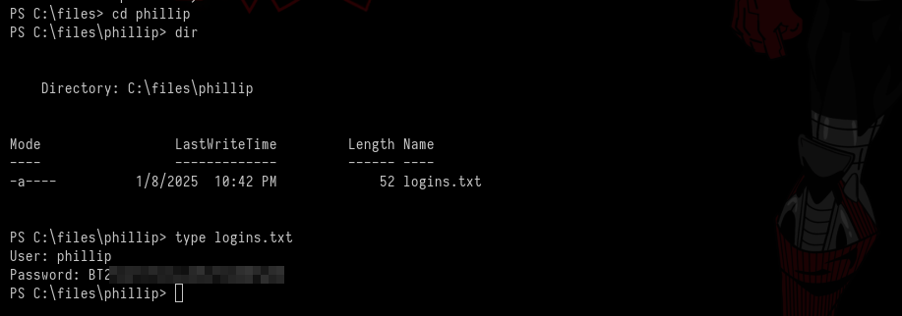Figure 11 - File containing user credentials.

This allows us to authenticate using WinRM, simplifying our process.

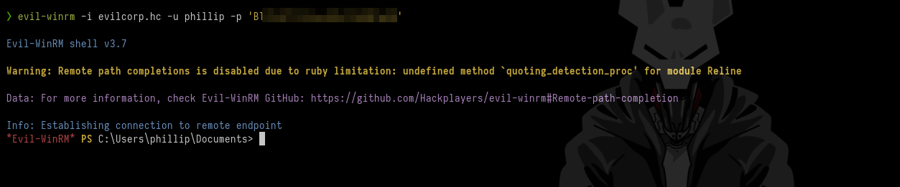Figure 12 - WinRM authentication.

Privilege Escalation – obtaining the root flag
After logging in via WinRM, we continue enumerating the machine for privilege escalation opportunities and find something very interesting.

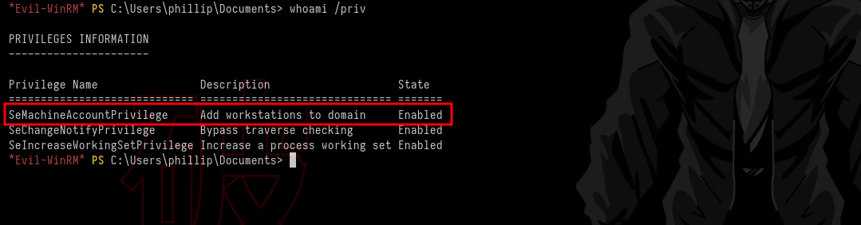Figure 13 - SeMachineAccountPrivilege enabled.

SeMachineAccountPrivilege is a Windows privilege that allows a computer account to create or modify its own machine account. This privilege is related to managing machine accounts and may allow adding them to specific groups, such as Domain Administrators.
We can add computers to the domain, which can be exploited to create new compromised machines or manipulate the configuration of existing ones.

impacket-addcomputer --computer-name NOSFERATU-01 --computer-pass 'Nosferatu01' -domain-netbios domain evilcorp.hc/phillip:REDACTED -dc-ip 172.16.8.223

Figure 14 - Adding a machine to AD.

With this, we successfully add a machine to Active Directory. Now, using netexec, we dump the information and send it to BloodHound. This tool allows us to identify attack paths and complex relationships between Active Directory objects, revealing access permissions that facilitate lateral movement and privilege escalation.

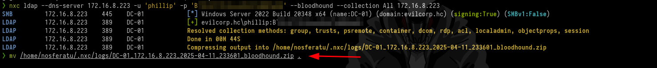Figure 15 - Extracting information for BloodHound.

nxc ldap --dns-server 172.16.8.223 -u 'phillip' -p 'REDACTED' --bloodhound --collection All 172.16.8.223

After this, we open BloodHound and observe in NodeInfo that LAPS is ENABLED.

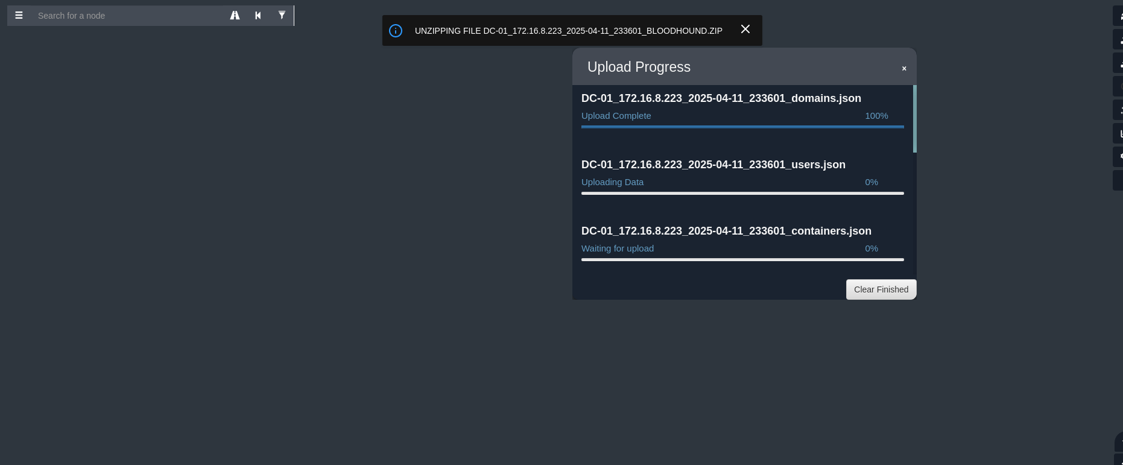Figure 16 - Importing data into BloodHound.

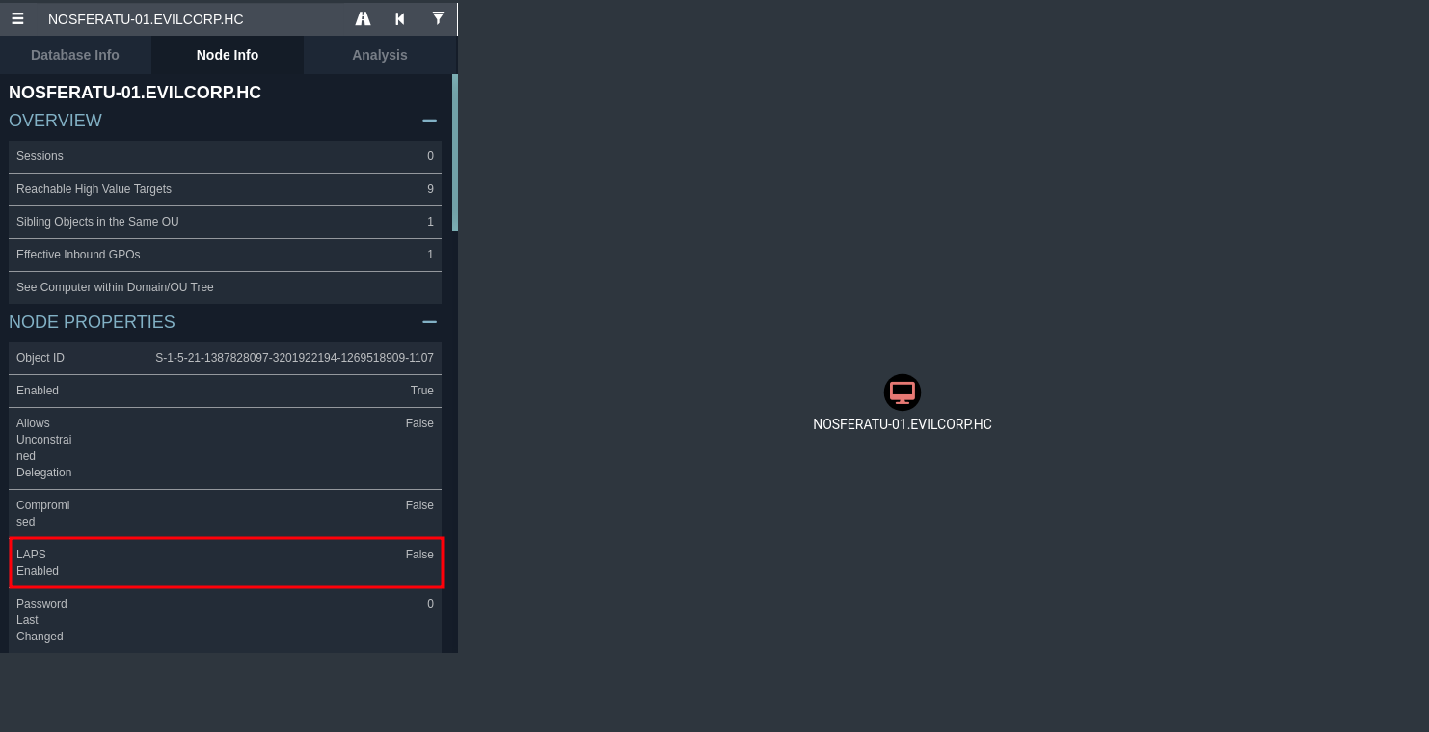Figure 17 - Enumerating the new machine.

LAPS (Local Administrator Password Solution) manages local administrator passwords on domain-joined computers. We can leverage this to our advantage.

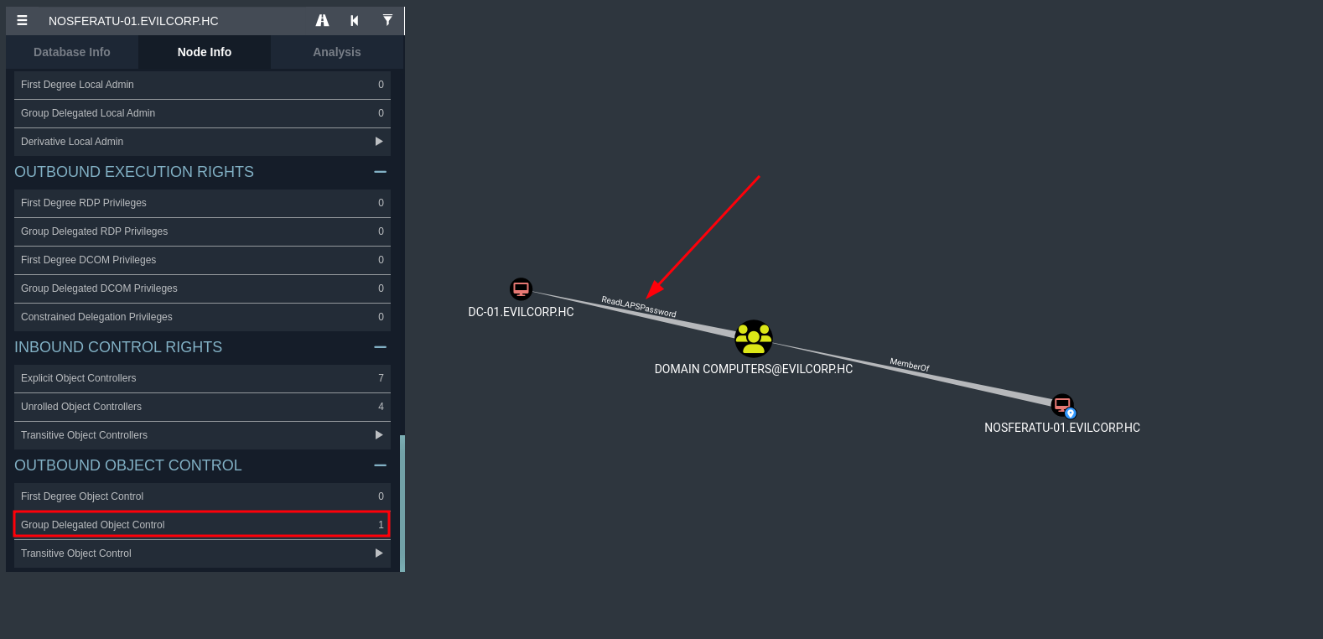Figure 18 - LAPS enabled.

We also notice that we have Outbound Object Control. “Group Delegated Object Control” refers to delegating permissions to groups to manage objects in Active Directory. This allows specific administrative tasks to be assigned without granting full access. An example of delegation is resetting passwords.

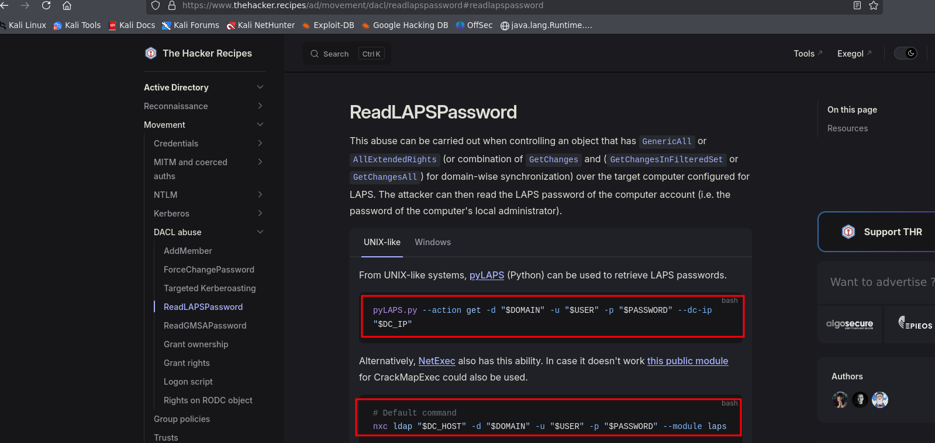Figure 19 - Tools for LAPS enumeration.

We could use pyLAPS.py for this, but I chose to continue using netexec. The process is simple:

nxc ldap "DC-01.evilcorp.hc" -d "evilcorp.hc" -u 'NOSFERATU-01$' -p "Nosferatu01" --module laps

Figure 20 - Obtaining the domain computer password.

With this, we retrieve the domain computer password and, consequently, the Administrator password. Now, we simply authenticate via WinRM as Administrator using the returned password, and inside the Administrator’s Desktop folder we obtain our root flag.

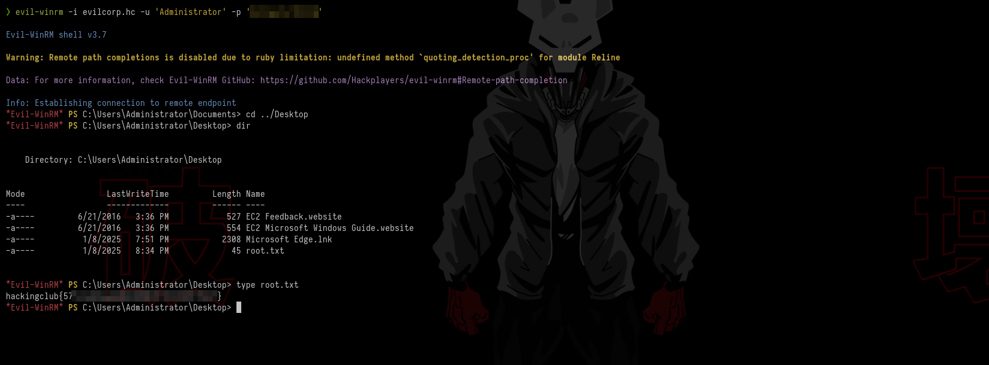Figure 21 - WinRM authentication as Administrator and retrieving the root flag.

